**Kevin Vu - Case 1**

**Erick Morales - Case 2**

**Osman Khan - Case 3**

**Anthony Dawson - Case 4**

# Use Cases and Scenarios

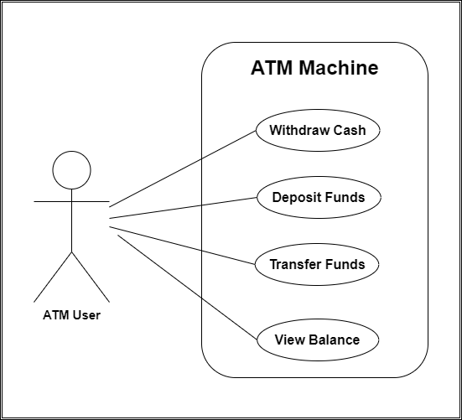

Case#1 - Kevin Vu

**Use Case Name:** Withdraw Cash

**Summary:** Customer will be able to use a pin number to withdraw funds from their bank account

**Actor:** ATM Customer

**Precondition:** Displays the welcome message and gives the user an option to choose cash withdraw

**Description:**

1. Customer enters their PIN account number into ATM

2. System will check if the pin number is correct

3. If the customer enters the PIN incorrectly, it will prompt the user again for the PIN.

4. The system will give a selection of options for the user to choose from

5. If the customer chooses withdraw funds, it will give the user an option to select which account type they want to withdraw from

6. The user selects savings or checking and then the system will check if the customer has enough funds to withdraw from and check if the daily limit has not been met

7. If the conditions are met, the machine will dispense the selected amount

8. System will print a receipt

9. System displays the home screen

**Alternative Flows:**

 (3) If the customer enters the wrong PIN, it will prompt an incorrect PIN message and ask the user to type in the PIN again.

 (6) If the customer types in an amount that exceeds the existing funds in the account, the system will display an exceeding message and the system will ask the user to type in a new amount

**Post Condition:** Funds are withdrawn from the customer’s account

**Non-Functional Requirement:** User friendly, Accuracy

Case #2 Erick Morales

**Use Case Name:** Deposit Funds

**Summary:** Customers will be able to use a PIN to deposit funds onto their account.

**Actor:** Customer

**Precondition:** Displays the welcome message and gives the user an option to choose deposit funds.

**Description:**

1. Customer enters their account PIN number into the ATM

2. System will recognize the PIN number

3. If the customer enters the PIN incorrectly, it will prompt the user again for the PIN.

4. The system will give a selection of options to choose from

5. Deposit function is selected

6. System will then prompt the customer to enter to his/her checking or savings account

7. System will ask the customer how much they want to deposit to their account

8. System will display a successful message and print a receipt

9. System returns to the welcome screen

**Alternative Flows:**

(3) If the customer enters in the wrong PIN, it will prompt an incorrect PIN message and ask the user to type in the PIN again.

(8)If nothing is inserted into the deposit cartridge the system will reset to the home screen.

**Post Condition:** Funds are deposited into the customer’s account

**Non-Functional Requirement:** User friendly, Accuracy

Case #3 Osman Khan

**Use Case Name:** Transfer Funds

**Summary:** Customers will be able to use a pin number to transfer funds between their checking and savings account.

**Actor:** ATM Customer

**Precondition:** Displays the welcome message and gives the user an option to choose transfer funds

**Description:**

1. System prompts the user to type in a PIN

2. If the customer enters the PIN incorrectly, it will prompt the user again for PIN.

3. The system will give a selection of options for the user to choose from one of them being transfer balance

4. Picking transfer balance will lead to a new menu that displays an option to pick which type of account they want to transfer from, either savings or checking

5. After an account type is picked the system will prompt a new menu of how much the user would like to transfer between the two balances

6. If the amount selected is enough for the account type, the balance is sent from the initial account to the selected one

7. The system displays a digital receipt that shows the amount transferred between the accounts

8. After the receipt displays the menu is taken back to the home screen

**Alternative Flows:**

 (2) If the customer enters in the wrong PIN, it will prompt an incorrect PIN message claiming no account is associated with that number and ask the user to type in the PIN again.

(6) If the account type has insufficient funds for transferring an error message will be displayed and the user is asked to enter an amount again

**Post Condition:** Funds are transferred between the customer’s account types

**Non-Functional Requirement:** User friendly, Accuracy

Case #4 - Anthony Dawson

**Use Case Name:**  View Balance

**Summary:** The bank customer will use a PIN to access their account and view the  balance within their checkings or savings through the ATM.

**Actor:** ATM User

**Precondition:** The ATM displays the main menu options.

**Description:**

1.  The system prompts the user to type in a PIN.

2.  If the customer enters the PIN incorrectly, it will prompt the user again for the  PIN.

3.  The system will give a selection of options for the user to choose from one of them being transfer balance.

4.  The customer selects view balance.

5.  The machine displays 3 options for the user to choose from(Checking, Savings, Return).

6.  The user will select either the Checking or Savings account to view.

7.  The machine displays the account name, its balance, and presents a return option.

8.  The user selects “Return”.

9.  The machine returns to display the main menu options.

10.  The user selects cancel.

11.  The machine ejects the card.

12.  The machine returns to the idle screen.

●   **Alternative flows:**

○   (2) If the customer enters in the wrong PIN, it will prompt an incorrect PIN message claiming no account is associated with that number and ask the user to type in the PIN again.

○   (5) If the customer selects return, the machine displays the main menu options again.

●   **Postcondition:**

○   The user has seen their account and its balance, and the machine is idle.

**Non-Functional Requirement:** User friendly, Accuracy